******SPONSORSHIP AGREEMENT**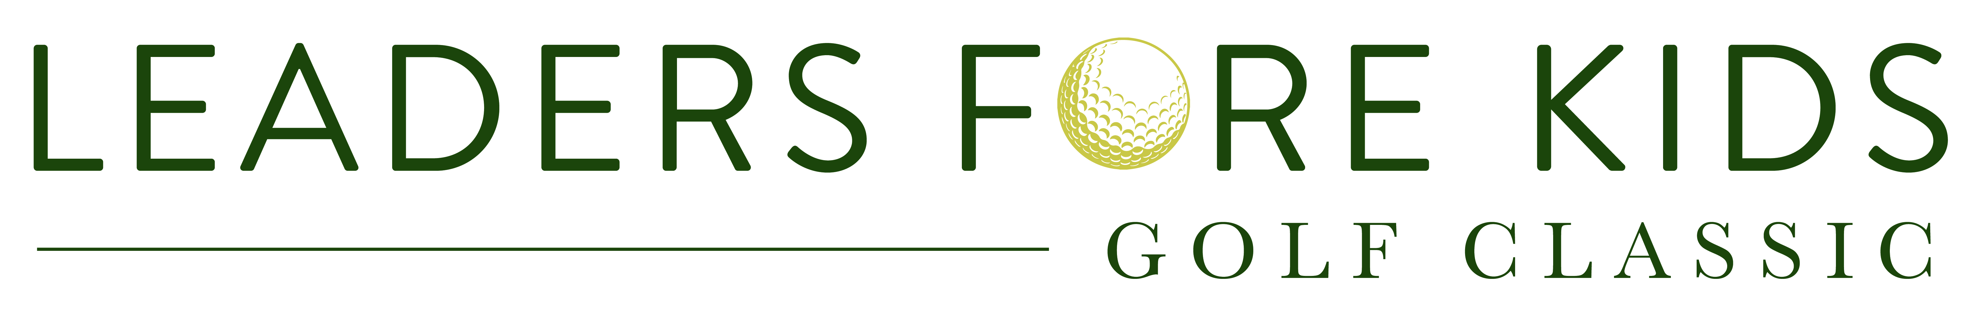

Presented by Alliant Insurance @ Colorado Golf Club, July 11, 2022

**Sponsor Company Name:** Click or tap here to enter text.

**Sponsor Contact Name:** Click or tap here to enter text.

**Address:** Click or tap here to enter text.

Click or tap here to enter text.

**Phone:** Click or tap here to enter text.

**Email:**  Click or tap here to enter text. **Website:** Click or tap here to enter text.

**DCF Representative:** Click or tap here to enter text.

**Standard Sponsorships:**

~~$30,000 Major Title Sponsorship~~ SOLD!!

~~2x Foursomes, 2x Cottages (8 guests), 2x pre-event foursomes, signage/ads, ball logos, SWAG item~~

$11,000 Eagle Sponsorship*

1x Foursome, 1x Cottage (4 guests), 1x pre-event foursome, signage/ads, SWAG item donation

$6,000 Elite Foursome*  
1x Foursome, hole signage

Golf + Polo Sponsorships**

1x Foursome + Fri-Sat-Sun Polo Table: $15,000**\***

$7,500 Banquet Sponsorship

1x Foursome, signage, website logo; $5,000 w/o golf

~~$5,000 Lunch Sponsorship~~ SOLD!!

~~Signage, website logo~~

$2,500 Breakfast Sponsorship

Signage, website logo

*Early Bird discount of $1,000 through May 1. **Early Bird discount of $1,000 through April 1.

**Describe any Modifications to standard pricing or deliverables:**

Insert modifications here. Modifications from the standard sponsorship above must be approved by Event Chair, Ben Farrow, benfarrow87@gmail.com.

Click or tap here to enter text.

**Sponsor Signature:** ________________________________ Date: ___________________

**Payment Method:**

*Check* *(Payable to Denver Children’s Foundation; PO Box 202684, Denver CO 80220-8684)*

*Credit card (contact me)*

*Please send me an invoice*

**DCF Authorization Signature**:______________________________ Date: ____________________

*Authorization allowed by Event/Sales Chair or Executive Director*