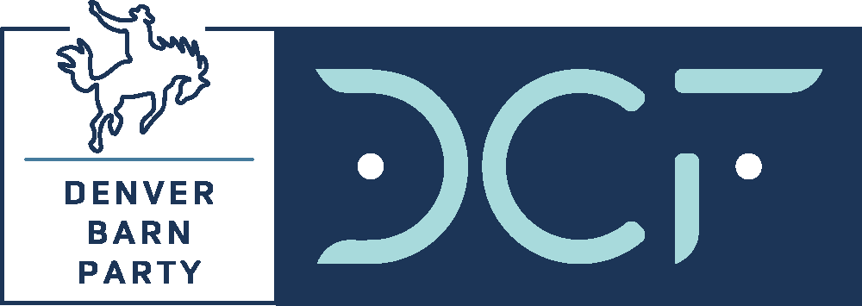
SPONSORSHIP AGREEMENT
Denver Barn Party @ the Barns at Columbine Valley
June 7, 2025
Back to the Barns with DCF!

Sponsor Company Name: Click or tap here to enter text.
Sponsor Contact Name: Click or tap here to enter text.
Address: Click or tap here to enter text.
Click or tap here to enter text.
Phone: Click or tap here to enter text.
Email: Click or tap here to enter text.

DCF Representative: Click or tap here to enter text.

Standard Sponsorships:

☐ $30,000 Major Title Sponsorship
Gold Buckle table for ten (10) VIP guests plus twenty (20) attendee tickets, event title banner and signage, email and social media marketing, website logo placement. SOLD!

☐ $15,000 Pre-Show Tailgate Sponsor
VIP tailgate area signage, Gold Buckle (10 VIP Reserved) + 10 VIP GA tickets, headliner meet-and-greet, social media
☐ $12,500 Stage or Bar Sponsor
Signage, Silver Buckle (8 VIP Reserved) + 10 VIP GA tickets, headliner meet-and-greet, social media
☐ VIP Table Sponsorships*
☐ Gold (10 VIP Reserved Tickets): $6,000
☐ Silver (8 VIP Reserved Tickets): $4,500
☐ Bronze (6 VIP Reserved Tickets): $3,000
☐ Boot Stomp (4 VIP Reserved Tickets): $2,000

*EARLY BIRD discount until May 1 ($500 for Gold and Silver). Sponsorships include pre-show Tailgate, reserved table in VIP-only restricted access area, hosted VIP-only bar and complimentary Tailgate food, VIP event entrance.

Describe any Modifications to standard pricing or deliverables:
Insert modifications here. Modifications from the standard sponsorship must be approved by Event Chair Matt Mansfield (mmansfield@crestins.com).

Sponsor Signature:______________________________ Date:____________________

Payment Method:
☐ Check (Payable to Denver Children’s Foundation; PO Box 202684, Denver CO 80220-8684)
☐ Credit card or ACH (contact me)
☐ Please send me an invoice

DCF Authorization Signature:______________________________ Date:____________________
Authorization allowed by Event/Sales Chairs or Executive Director

